Task 1: Divide 192.168.10.0/24 into 4 Equal Subnets

Given network: 192.168.10.0/24
To create 4 equal subnets:
- Required subnets = 4
- 2² = 4, so we borrow 2 bits from the host portion.
- New CIDR = /26
- Subnet Mask = 255.255.255.192
- Total addresses per subnet = 64
- Usable hosts per subnet = 62
Subnet | Network Address | Usable Host Range | Broadcast Address
Subnet 1 | 192.168.10.0/26 | 192.168.10.1 – 192.168.10.62 | 192.168.10.63
Subnet 2 | 192.168.10.64/26 | 192.168.10.65 – 192.168.10.126 | 192.168.10.127
Subnet 3 | 192.168.10.128/26 | 192.168.10.129 – 192.168.10.190 | 192.168.10.191
Subnet 4 | 192.168.10.192/26 | 192.168.10.193 – 192.168.10.254 | 192.168.10.255
Subnet Mask for all four subnets: 255.255.255.192

Task 2: Assigning 5 devices in Subnet 1 (192.168.10.0/26)

Allocated Subnet: 192.168.10.0/26
- Network Address: 192.168.10.0
- Usable range: 192.168.10.1 – 192.168.10.62
- Broadcast Address: 192.168.10.63
- Subnet Mask: 255.255.255.192
Device | IP Address | Subnet Mask
Router | 192.168.10.1 | 255.255.255.192
Laptop 1 | 192.168.10.2 | 255.255.255.192
Laptop 2 | 192.168.10.3 | 255.255.255.192
Printer | 192.168.10.4 | 255.255.255.192
Mobile | 192.168.10.5 | 255.255.255.192
The network address 192.168.10.0 and broadcast address 192.168.10.63 are not assigned to devices.

Task 3: Subnet Plan Network Architecture Diagram

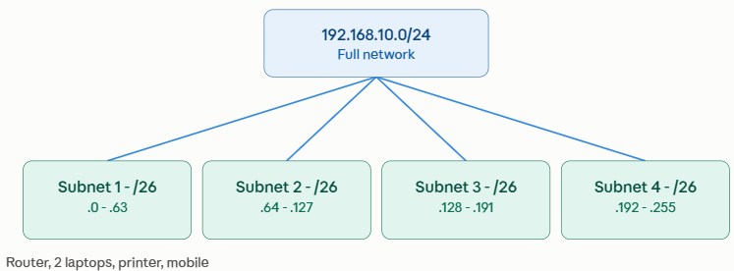
Subnet Plan
Subnet 1: 192.168.10.0/26
Devices:
Router → 192.168.10.1
Laptop 1 → 192.168.10.2
Laptop 2 → 192.168.10.3
Printer → 192.168.10.4
Mobile → 192.168.10.5

Subnet 2: 192.168.10.64/26
Range: 192.168.10.65 – 192.168.10.126
Subnet 3: 192.168.10.128/26
Range: 192.168.10.129 – 192.168.10.190
Subnet 4: 192.168.10.192/26
Range: 192.168.10.193 – 192.168.10.254

Task 4: Step-by-Step Subnetting Explanation (Beginner's Guide)

Step 1: Figure Out How Many Bits to Borrow
- Start with what was given: 192.168.10.0/24. The /24 means the first three octets (24 bits) are fixed as the network part, and the last octet (8 bits) is free for host addresses.
- Figure out how many bits to borrow: You need 4 subnets, so ask "what power of 2 gives me 4?" — 2² = 4, so you borrow 2 bits from the host portion.
Step 2: Write Down the New Subnet Mask
- Add the 2 borrowed bits to the original prefix: $24+2=/26$.
- Look at the 4th octet in binary. The first 2 bits are now 1s and the remaining 6 bits are 0s:
$${11000000}_{2}=128+64=192$$
- Your new subnet mask across all four subnets is 255.255.255.192.
Step 3: Find the Block Size (Magic Number)
- The block size tells you where each new subnet starts.
- Subtract the interesting octet value from 256: $256-192=64$
- Each subnet increments in blocks of 64:
- Subnet 1 starts at .0
- Subnet 2 starts at $0+64=$ .64
- Subnet 3 starts at $64+64=$ .128
- Subnet 4 starts at $128+64=$ .192
Step 4: Calculate Hosts per Subnet
- Remaining host bits ($h$): $8-2=6\text{ bits}$.
- Total IP addresses per block: $2^{6}=64$.
- Usable host IPs formula: $2^{h}-2=64-2=62\text{ usable hosts}$.
- Why subtract 2? The very first address in each block is the Network ID (identifies the subnet), and the very last address is the Broadcast ID (sends data to every host in that subnet at once). Neither can ever be assigned to an individual device.

